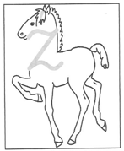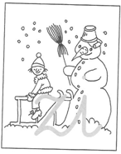

ź czy zi?

**1.** Przepisz

|  |
| --- |
|  |
|  |
|  |
|  |
|  |
|  |

|  |
| --- |
|  |
|  |
|  |
|  |
|  |
|  |

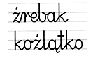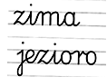

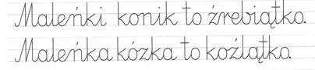**2.** Napisz zdania z pamięci.

|  |
| --- |
|  |
|  |
|  |
|  |
|  |
|  |

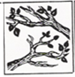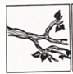**3.** Podpisz obrazki





|  |
| --- |
|  |
|  |
|  |

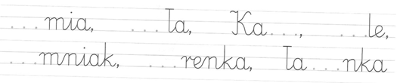**4.** Uzupełnij wyrazy podanymi sylabami: ***zia, zio, zie***

**5.** Napisz wyrazy w odpowiedniej kolejności tworząc sensowne zdania.

|  |  |  |  |  |  |  |  |  |
| --- | --- | --- | --- | --- | --- | --- | --- | --- |
| **Kazia.** |  | **To** |  | **pani** |  | **jest** |  | **woźna** |

|  |
| --- |
|  |
|  |
|  |

|  |  |  |  |  |  |  |  |
| --- | --- | --- | --- | --- | --- | --- | --- |
| **wodę** |  | **źródła.** |  | **Weź** |  | **ze** |  |

|  |
| --- |
|  |
|  |
|  |